Compression using character runs
1.Problem:
Encode a string by grouping consecutive repeated characters and compare original and encoded lengths.
2.Objectives:
To compress string like aaa bbb to a3b3 , to check if beneficial.
3.Assumptions:
Input is lowercase string , count the consecutive chars.
4.Algorithm:
Start the input strings
Count=1 loop I from 1 to len(s)-1
If s==s[i-1] count++
Else add s[i-1]+count to compressed and reset
Add last char
Compare lengths
End
5.Pseudo code:
Read s compressed
Count=1 for I 1 to len(s)-1
If s==s[i-1] count++
Else compressed +=s[i-1]+str(count) count=1
Print(compressed)
6.Test cases:
T1 | aaa bbb | A3b3 length 4 vs 6 | beneficial
T2 | abc | A1b1c1 length 6 vs 3 | Not beneficial
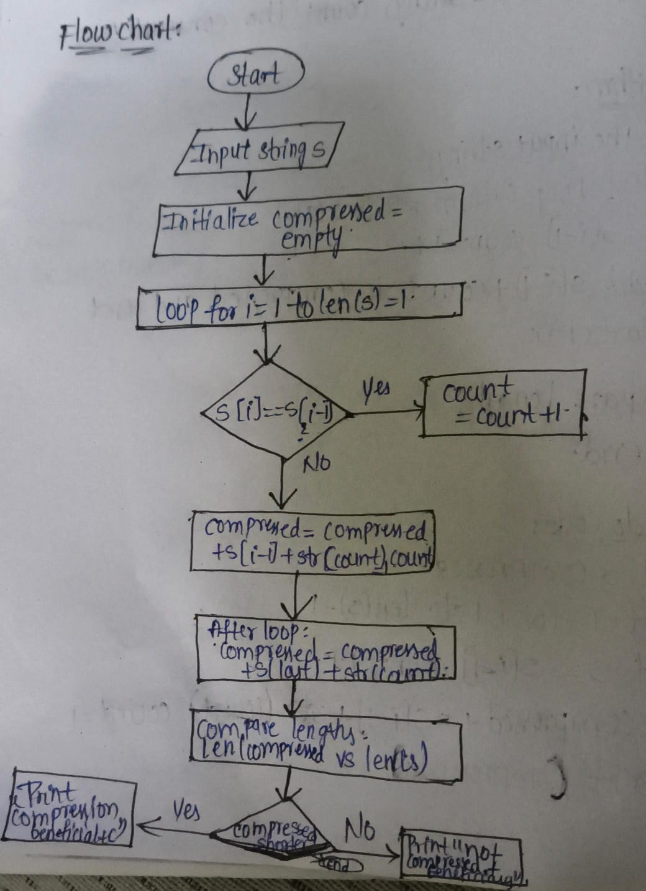
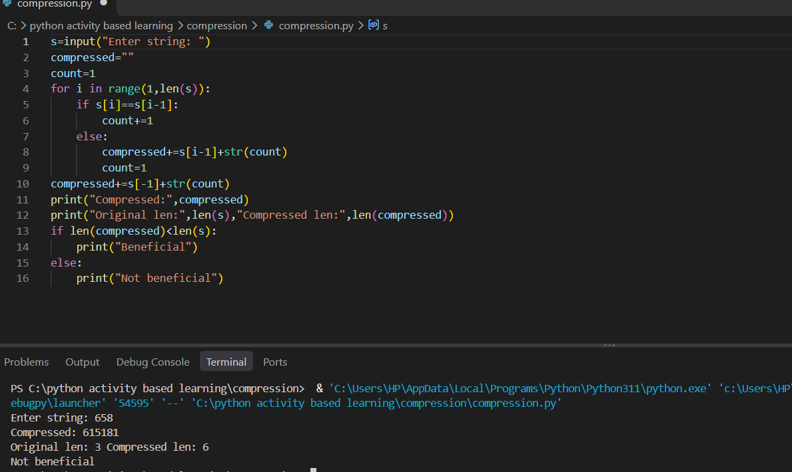
Conclusion:
All test cases are passed . Run length encoding implemented using loops and strings

